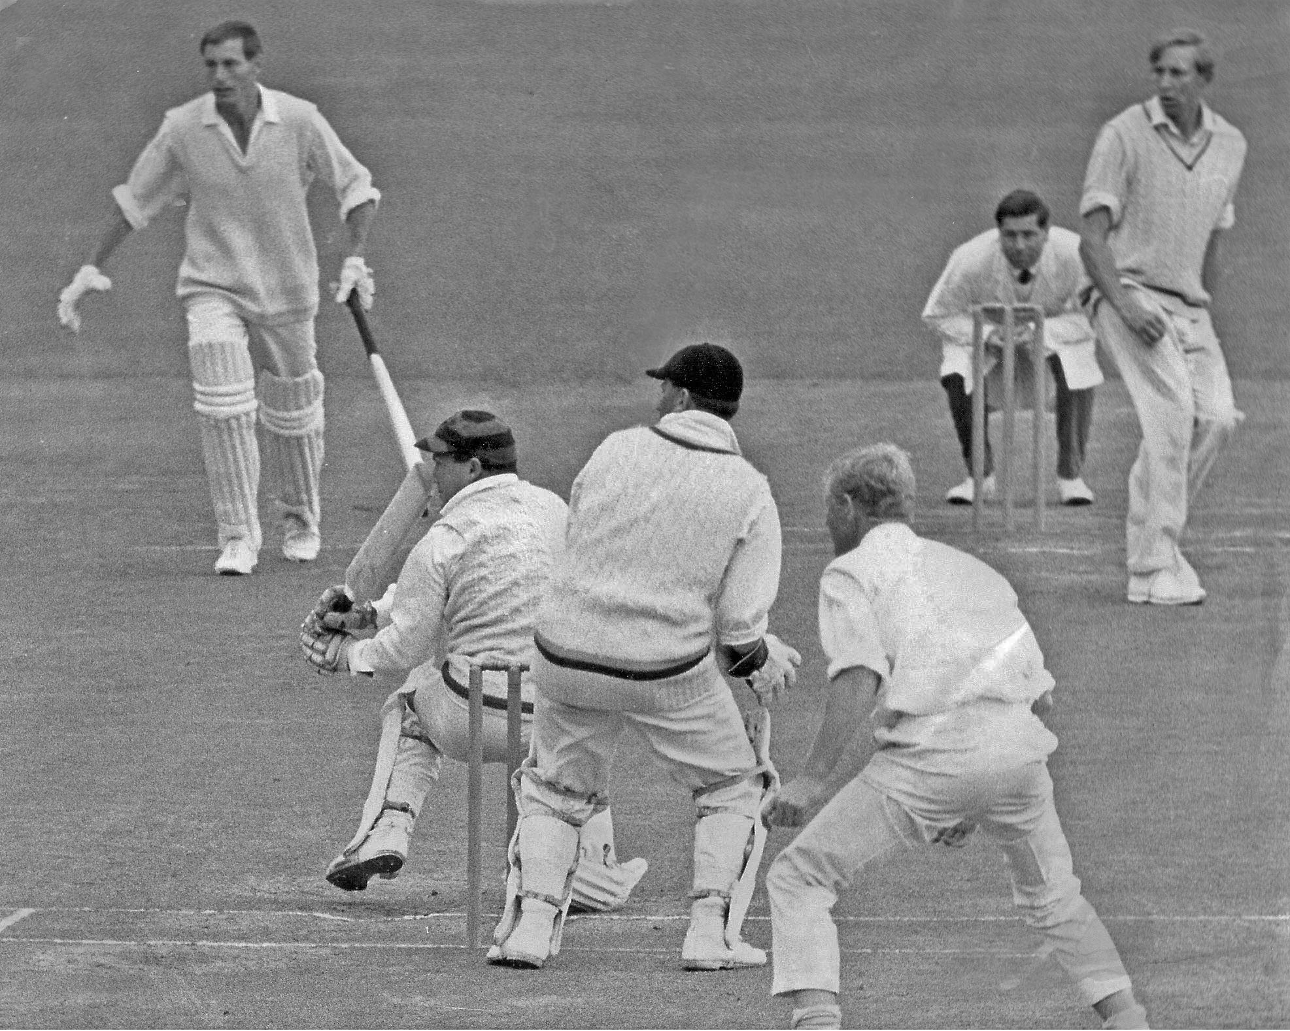

**K Thompson sweeps the ball for a boundary in the first over, overnight 37 not out he was 64 not out**

**when the innings was declared close. CL Broad non striker, BAG Murray bowler. Lancaster Park 3 January 1967**

**Canterbury 207 and 325/6 dec. Wellington 175 and 233. Canterbury won by 124 runs**